Name _______________________________________________________ Section __________________
Planet Baseball Cards
SLE: Identify the objects and how they move within the solar system
Identify some of the unique characteristics of planets

You will be creating 8 Baseball cards for the 8 different planets in the solar system. On the cards you will need to have:

Front
Earth

Back
Rotation in Earth Days= 1
Rotation in Earth Days= 1

Revolution in Planet Days= 365 ¼

Composition= rocky

Atmosphere= Nitrogen (77%) Oxygen (21%)

Moons= 1

Other interesting Facts: This is the only planet that has Oceans and Life

Name of the Planet
Drawn Picture of the planet

-Rotation in Earth Days (planet Information worksheet)
-Revolution in Earth Days (planet information worksheet)
-Revolution in Planet Days (how many times the planet
turns around (day/night) for every time the planet goes around the Sun (year))
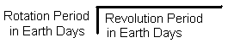
-Composition (planet Information worksheet)
-Atmosphere (planet Information worksheet)
-Moons (planet Information worksheet)
-Other interesting facts (extra fact off planet worksheet)

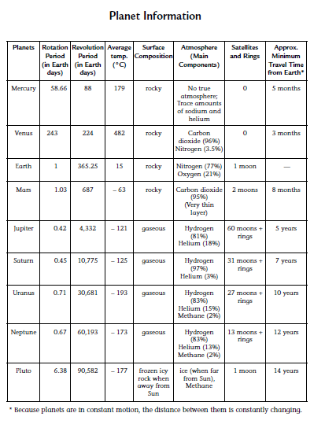

Use this paper as your cards one square is your front the other is the back

